New Tasks 2020-09-30

- Arrow direction
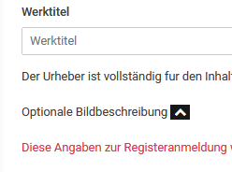
the arrow should point down before unfolding...
----------------------------------------------------------------------------------------------------------

- The Field positions in the Profile Page should be changed
(the same position as in the Resultpage and the PDF)

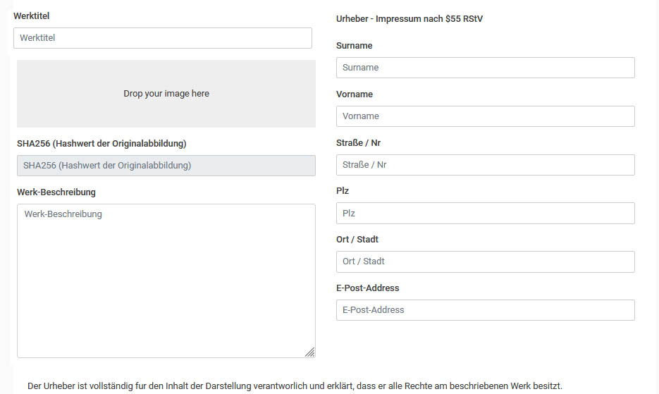
First: Werktitel
second: Image upload
.
.
.
.and at the end the Peronal Data

-------------------------------------------------------------------------------------------

- Image-caption:
can you put the copyright sign in front of the image-caption?

---> © cc-by-nd-ccroipr-20200930204532123
---------------------------------------------------------------------------------------------------------------

- PDF-Layout

a) I want to change the position of the fields in the PDF
and
b) in addition, the text lines should have less spacing and be closer together so that there is more space for the image.
c) the display of the image should also be limited in height

PDP-Layout Problem
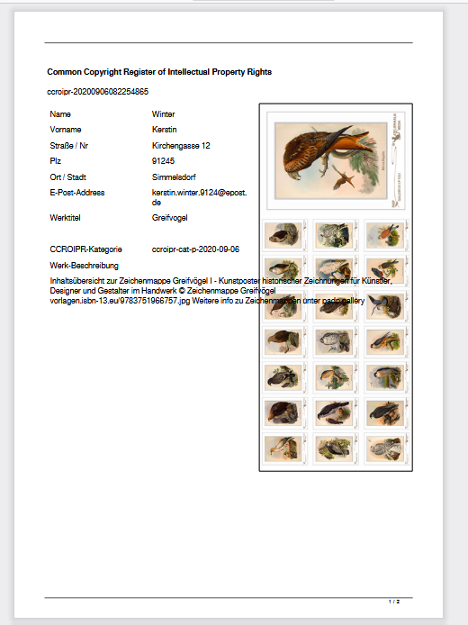
PDF-Layout Solution
----------------------------------------
